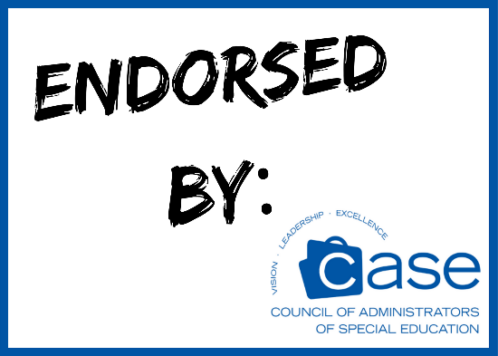 CASE Endorsed Products
Product | Description | Company | Countries | Benefits to Members
Accelerated Reader 360® | Online program to support independent reading and instruction for grades K-12 | Renaissance Learning | USA  Canada | Subscription volume  discounts
Caselite | Web-based system for scheduling, intervention tracking, record-keeping, and workload analysis for related service providers such as SLPs, OTs, PTs, VI, HI, and others | Caselite Software, Inc. | USA | 10% Discount
CHAMPS | Program on positive classroom behavior management for K-12 educators (Tier 1) | Safe and Civil Schools  Division of Teaching Strategies, Inc. | USA  Canada | 15% Discount
Classworks | Supplemental instructional software K-8 (e.g., reading, math, science, performance tasks) | Curriculum Advantage, Inc. | USA | 10% Discount
Corrective Reading | Develop tightly sequenced, carefully planned lessons to give struggling students the structure and practice necessary to become skilled, fluent readers. | McGraw Hill | USA
Early Interventions in Reading | Solid research is at the heart of this product. Designed to work comfortably with core reading programs. | McGraw Hill | USA
EasyIEP | Customizable web-based, special education workflow and data management solution. | Public Consulting Group, Inc. (PCG) | USA  Canada | TBD
eIEP PRO | Customizable web-based software for educators to manage the special education process | Media Net Solutions | USA | 30% Discount on initial purchase; 20% Discount on training
Fast ForWord® | Language program that builds foundational skills needed for language, learning, and reading | Scientific Learning | USA Canada | 5% Discount on Products
Foundations | Program on positive school-wide behavior management for K-12 educators (Tier 2) | Safe and Civil Schools  Division of Teaching Strategies, Inc. | USA  Canada | 15% Discount
Interventions | Program on positive behavior interventions for K-12 educators  (Tier 3) | Safe and Civil Schools  Division of Teaching Strategies, Inc. | USA  Canada | 15% Discount
iStation Reading Curriculum and Assessments | Internet-based assessment and reading intervention program | iStation | USA  Canada | 20% Discount
Lexia Reading | Technology–based reading program grade level K-4 | Lexia Learning Solutions | USA  Canada | TBD
MindPlay Virtual Reading Coach | Online, self-paced, mastery-based reading intervention program | Mind Play | USA  Canada | 6 months use of RAPS360 with purchase of MRC
ParaEducator PD Now | Online modules for use with para-educators | The Master Teacher | USA  Canada | 10% Discount
Positive Action | Program that improves academics, behavior, and character | Positive Action, Inc. | USA  Canada | 10% Discount
Project Discovery | Explore, experience, learn and develop real life job skills and tools while reinforcing core academic skills. | Education Associates | USA
Read 180 New Generation | Curriculum, instructional tools, and assessment intervention for grades 4–12+ | Houghton Mifflin Harcourt | USA  Canada | 15-20% Discount
Reading Horizons | Multi-sensory phonics and foundational reading program | Reading Horizons | USA  Canada | TBD
Reading Mastery Signature Edition | SRA workbook package for direct instruction of reading. | McGraw Hill | USA | TBD
Robots4Autism | Robot-centric engagement platform for social and behavioral skills development. | Robokind | USA | TBD
Seeing Stars | Program for teaching symbol imagery for phonemic awareness, sight words, and spelling | Lindamood-Bell Gander | USA  Canada | 10% Discount
Special Ed Connection | Web-based publication on special education legal issues | LRP Publications | USA | 2 additional months
SuccessMaker  K-8 Reading | Online K-8 math and reading program that identifies gaps, adapts instruction to meet individual needs, and builds mastery. | Pearson Digital Learning | USA Canada | TBD
Synergy SE | Secure program that stores student IEPs and related documents in one central database while delivering instant access to the case file | EduPoint | USA  Canada | 5% Discount
System 44 | Intervention (Tier 3) for reading and phonics for Grades 3–12+ | Houghton Mifflin Harcourt | USA | 10% Discount
Visualizing and Verbalizing | Program that develops concept imagery as a basis for higher-order thinking and comprehension | Lindamood-Bell Gander | USA  Canada | 10% Discount
VizZle | Online storehouse of instructional materials, data tracking tools, and generated reports as a vehicle for implementing interventions to students with Autism. | Monarch Teaching Technologies | USA  Canada | 10% Discount
Waterford Early Learning Reading (WELR) | Language arts curriculum for grades PreK-2 that teaches crucial skills for all early learners: phonological awareness, phonics, comprehension, vocabulary, language, concepts, and fluency | Waterford Research Institute LLC | USA | 5 free licenses

